UPDATE ON STANDING ITEMS FOR PARISH COUNCIL MEETING 3 NOVEMBER 2021

Village Hall
The legal work to rectify the error made by South Northamptonshire Council lawyers is progressing satisfactorily and the new trustees have been asked to confirm that the revised plan of the boundary is now correct. Once this has been completed it will be possible to rectify the details held by the Land Registry.
Once the asset has been transferred to the new CIO then the Parish Council will cease to be a trustee.

War Memorial
Our thanks are due to Bob Bellhouse, who undertook the work on the plinth, as he agreed to install the wooden surround on a pro bono basis. Subsequently, the Chair of the Parish Council laid the weed membrane that had been donated and covered the area with pea gravel paid for from profits from the sale of “The Wicken Men”.

Flood Prevention
The Parish Council has been advised by Andrew Edmondson that some trees alongside the brook are to be felled at the request of homeowners adjoining the brook who are concerned about the loss of light in their gardens. The trees on the left of this picture are affected.
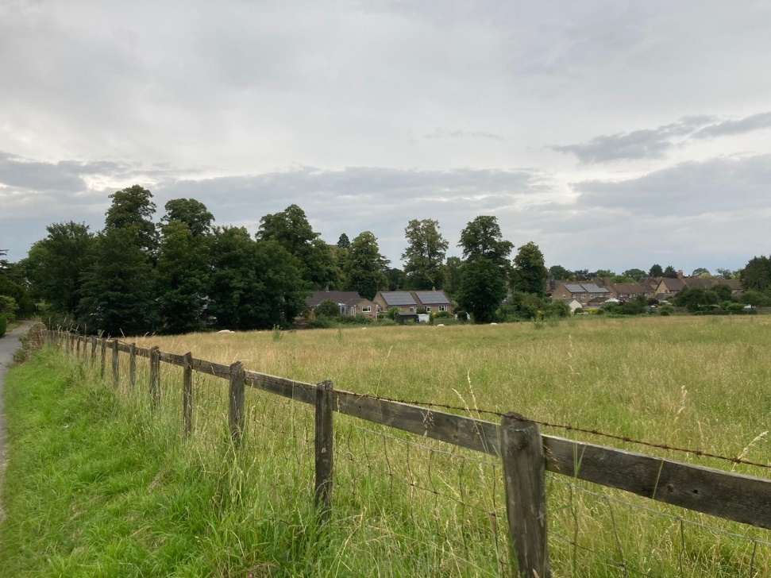

Akeley School Entrance
Although the white lines have now been repainted we have received reports of two near misses at this junction from a village resident. A further letter has been written to the Principal of the Junior School requesting that further action be taken.

Road condition and overhanging trees/bushes;
Pothole work completed, to a good standard generally.
Streetlighting
Order placed and awaiting confirmation of delivery-installation from EON, there is a good chance it will be completed before Christmas.
The maintenance rebate from the time the original 13 LED street lights were installed in June 2020, was only applied from the quarter starting the 1st April 2021. I am chasing EON for the missing three quarters, the total rebate due is £97.11.
New solar farm
Update from Elgin;
The main activities we have been carrying out is the submission of information to the council to discharge the conditions including the section 50 for the cable route. You may have noticed some activity on the planning file in recent weeks.
We expect to be able to share project programme with you in January.
Work expected to start in 2Q 2022.

Speed Camera stats
Installed | 04/09/2017
It takes 2 Speeds When vehicle is first timed and last timed.
 |  | First timing |  | Second timing
 | Total | over 30 MPH | Over 30% | over 30 MPH | Over 30% | Over 40 MPH | Over 40%
 | 145004 | 36945 | 25.48 | 9174 | 6.33 | 442 | 0.30
 | total | over 30 MPH | Over 30% | over 30MPH | Over 30% | Over 40 MPH | Over 40%
2017 | 9624 | 1403 | 14.58 | 70 | 0.73 | 1 | 0.01
2018 | 72208 | 15673 | 21.71 | 4156 | 5.76 | 220 | 0.30
2019 | 63172 | 19869 | 31.45 | 4948 | 7.83 | 221 | 0.35
 | Gap in data 8 August to 11 September 2020 due to flat batteries.
2020 | 43522 | 5821 | 13.37 | 993 | 2.28 | 39 | 0.09
2021 | 45640 | 11561 | 25.33 | 2990 | 6.55 | 89 | 0.20
 | Data up to 26/10/21

Update from Path Wardens
On October 21st. the Council ran an online training course for Path Wardens led by Leon Jolly. It was helpful and informative. They have said they are going to send copies of the slides they used out, in which case I will share them with the PC. They gave details of the regulations regarding maintaining pathways, bridle ways and byways and the appropriate rules on width, types of gates and so on. They are trying to encourage landowners to replace stiles with gates to make the walks accessible to more people.
Once again they stressed that people should be encouraged to report problems using Street Doctor/ Fix My Street, failing that report to me and I will report them. They also reiterated the Health and Safety issues if we undertook maintenance work ourselves. They are working with their insurance company on that, but if we have a project we want to do as a community we might be able to do it under the village insurance, though Leon would like input first as there are issues he would raise.
He stressed the importance of the PWWs liaising with the Parish Council and the importance of encouraging the community to use the Rights of Way. One topic for discussion that they mentioned is the development of Permissive Paths in a parish.
They seemed genuinely interested in encouraging people to walk and explore and mental health benefits were mentioned. Of course, budget limitations are a factor, but really not so much for a small village like Wicken. Some attendees were asking for walking bridges to be built over major roads.

Update from Henry Syrett on the Warren
Villagers may note some disruption on the footpath along the Warren in the coming weeks. We have removed the old post-and-rail fencing from the footpath as it was very rotten and falling over in places and was looking unkempt (unfortunately we also had to clear the path of a bough of the apple tree which came down in the winds at the weekend, but that was unrelated). We will be repairing the fencing in the coming weeks with metal estate fencing. The new fence will be in keeping with the existing metal fencing alongside the Gospel Elm and on the corner near to the commemorative bench. We will replace the kissing gates at the edges of the field as they had also been subject to a number of repairs which were only going to last so long. We will also be moving the fencing to the other side of the path that crosses the Warren; this will mean that walkers will only have to walk through one field instead of both, and negotiate two kissing gates instead of three. Just for clarity, there will be no change to the route of the footpath.

We apologise for any disruption over the coming weeks but hope that everything should be in place by the end of November - if you would like to use the footpath whilst the work is being done please feel free to stray into the bottom field slightly to avoid the works - we will not currently have any stock or horses in there until the works are completed.

